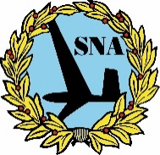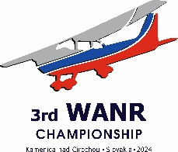

OFICIAL ENTRY FORM FOR OFFICIALS

3rd FAI WORLD AIR NAVIGATION RACE CHAMPIONSHIP Kamenica nad Cirochou 2024,

Slovak Republic From the 19th to25th August 2024

The undersigned member of _________________________________ National Aero Club wishes to enter to participate in the 3rd FAI WORLD AIR NAVIGATION RACE CHAMPIONSHIP Kamenica nad Cirochou 2024:

|  |  |  |  |
| --- | --- | --- | --- |
| President of Jury*□ | International Chief Judge*□ | FAI Official*□ | Local Chief Judge*□ |
| Route Planner*□ | Scoring Manager*□ | Competition Director*□ | Deputy competition Director*□ |
| Full name: | | Profession: | |
| Address: | | Country: | |
| Date of birth: | | T-Shirt size: | |
| Date: Arrive: _________________________________ Depart: ___________________________________ | | | |
| Short biography: | | | |
| Date: ______________________________________ | | Signature: __________________________________ | |
| Please return no later than **May 31th 2024** by E-mail: [aeroklubkamenica@gmail.com](mailto:aeroklubkamenica@gmail.com) or by mail to:  Aeroklub Kamenica, o.z. Štefánikova 4 066 01 HUMENNÉ  Slovak Republic  * tick appropriate box | | Please insert your digital photo here: | |