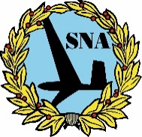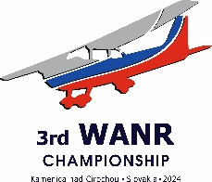

PRELIMINARY ENTRY FORM

3rd FAI WORLD AIR NAVIGATION RACE CHAMPIONSHIP Kamenica nad Cirochou 2024,

Slovak Republic From the 19th to25th August 2024

The__________________________________ Aero Club of _______________________________________________

Hereby applies for preliminary entry into the 3rd FAI WORLD AIR NAVIGATION RACE CHAMPIONSHIP Kamenica nad Cirochou 2024 to be held in Slovak Republic, with following:

|  |  |  |
| --- | --- | --- |
| Competition Crews: | Reserve Competition Crews: | International Judge(s): |
| Judge Observer(s): | Team Manager: | Engineer(s): |
| Observer(s): | Supporter(s) / Spectator(s): | Total number: |
| During the competition we expect / wish to book and pay: Single Rooms & Double Rooms | | |
| **Extra nights:**  Before the competition we expect/wish to book and pay: _____ Single Rooms, from ____________ up to 19/08/2024  _____ Double Rooms, from ___________ up to 19/08/2024  After the competition we expect/wish to book and pay: _____ Single Rooms, from 25/08/2024 till _______________  _____ Double Rooms, from 25/08/2024 till _______________ | | |
| We would like to hire the following type of aircraft: ____________ Cessna 150/152, __________ Cessna172 | | |
| Please mail further information on the Championships to the following address:  Postal:  E-mail: Date: Signature & Stamp: | | |
| **Licencing issues for pilots hiring an aircraft:**  ______ pilots are holder of a licence including a valid class rating for SEP and a valid Medical, according to Regulation (EU)  1178/2011 [ LAPL(A) + LAPL medical, or PPL(A) + at least Medical Class 2].  ______ pilots are already holder of a valid third country licence and a valid medical (all ICAO compliant) and a validation,  according to Regulation (EU) 1178/2011.  ______ pilots need to apply for a licence validation and hold a valid third country licence and a valid medical (all ICAO compliant) | | |
| We need assistance in obtaining visas to enter the Slovak Republic: YES □ NO □ | | |
| Other requirements: | | |
| Please return no later than **April 30th 2024** by E-mail: [aeroklubkamenica@gmail.com](mailto:aeroklubkamenica@gmail.com) or by mail to:  Aeroklub Kamenica, o.z. Štefánikova 4 066 01 HUMENNÉ  Slovak Republic | | |