
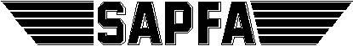


South African Power Flying Association
a section of
The Aero Club of South Africa

50 Hurricane Road, Rand Airport, Germiston, South Africa
Phone: +27 (011) 082 1100
E-mail: office@aeroclub.org.za
In association with

Brits Flying Club
Brits Airfield,
0250
TEL: +27 71 444 0928

Final Bid

FOR THE ORGANISATION OF THE

22nd FAI WORLD RALLY FLYING CHAMPIONSHIP

Brits Airfield
North West
South Africa

13-19 November 2022

a) Name and address of bidding National Aero Club (NAC).

The Aero Club of South Africa

50 Hurricane Road, Rand Airport, Germiston, South Africa
Phone: +27 (011) 082 1100
E-mail: office@aeroclub.org.za

b) Name and address of organization delegated by the NAC to organize the event (if any).

South African Power Flying Association
In association with

BRITS FLYING CLUB
Brits Airfield,
0250
TEL: +27 71 444 0928

c) Experience in organizing the relevant type of competition.

The South African Power Flying Association has hosted:

- 1991 - 7th World Rally Flying Championships– Stellenbosch Airfield

- 2003 - 13th World Rally Flying Championships– Pilanesberg Airfield

- 2011 - 20th World Precision Flying Championships – Brits Airfield

- 1937 to 2018 – President’s Trophy Air Race – the oldest and most prestigious Air Race in the World

- Competition officials have competed in most of the World Rally and Precision Flying Championships since as far back as 1977 (Wels, Austria)

- In 2020, the Aero Club of South African and the South African Power Flying Association celebrated their 100th birthday, which although planned as the initial year for the 22nd WRFC, this competition will still encompass the centenary celebration.

d) Name, address and relevant experience of the competition director appointed by the organizer.

Rob Jonkers
50 Middlehill Rd, Cornwall Hill, Irene
South Africa
email: rob@aerosud.co.za
mobile: +27 82 804 7032

Rob Jonkers has been flying since 1980, and took up the sport of Rally Flying in 2007, and competed in various local events since, with a first National Event in 2014, and qualified for the Protea Team to take part in International Competitions.

Rob has competed in 3 World Rally Flying Championships, the 19th, 20th, 21st in Poland, Portugal and Slovakia respectively.

Rob has also been Competition Director for a number of Rally National Championships since 2016, as well as for the Presidents Trophy Air Race as an FAI event. Rob has also taken up the role of judge at the Presidents Trophy Air Race and National Rally competitions.

He also serves as the Chairman of the South African Power Flying Association since 2017 and as the Chairman of the South African NAC – The Aero Club of South Africa – since 2020.

e) The proposed date of the event.

22nd FAI WORLD RALLY FLYING CHAMPIONSHIP

5th to 12th Nov 2022 Unofficial practice

13th Nov (SUN) Final arrival, Opening Briefing and Opening Ceremony
14th Nov (MON) First competition flight
15th Nov (TUE) Second competition flight
16th Nov (WED) Third competition flight
17th Nov (THU) Fourth competition flight
18th Nov (FRI) Reserve day, Prize-giving and Closing Ceremony
19th Nov (SAT) Departures

f) The venue (name of city and airfield).

It is proposed to host the 22nd FAI World Rally Flying Championships 2022 at Brits Airfield in the North West, close to the Magaliesberg hills. It is 95 km from Johannesburg which is a 1 hour drive or a half hour local flight from one of the many Johannesburg located GA airports.

Local Time UTC+2

g) Airfield infrastructure that will be available for the competition (runway length and condition, elevation, equipment, buildings, facilities, ATC, other traffic, etc.).

Brits Airfield (FABS) has been the venue for many flying competitions including Rally Flying and the World Precision Flying Championships in 2011. It is situated 5 km from Brits Town.

Coordinates: 25°31′56.4″ S / 27°46′29.45″ E
Elevation: 3,740 MSL
RWY :02/20 2952 ft (900 m) Asphalt
Freq: 124.200 MHz
VAR: 18.3 deg W
Fuel: AvGas 100LL and Mogas

Brits Airfield (FABS) meets all the requirements for competition facilities

- Briefing Rooms
- Team managers post boxes for information distribution
- Adequate toilet facilities
- Covered areas where pilots can wait
- 10 minutes from Accommodation facilities
- Food Stalls will be made available in a marquee – to sell drinks, snacks and lunches which will be provided to the competitors on competition days

h) Weather history of the area at the relevant time of the year (air temperature, wind, thunderstorms, etc.).

Average values of 20 years in: | Oct | Nov | Dec
Average temperature: | 23° C | 24° C | 25° C
Average daily minimum: | 15°C | 16°C | 17°C
Average daily peak: | 27°C | 28°C | 29°C
Amount of precipitation: | 60 mm | 80 mm | 100 mm
Daily chance of Precipitation | 30% | 40% | 50%
Average Wind Speed | 5 – 8 kts | 5 – 8 kts | 5 – 8 kts

While Brits is part of the summer rain fall area, rain is normally in the form of thundershowers that manifest in the mid to late afternoon, with thermal activity after midday.

Our route planners will create mountain routes and flat land routes to take into account the local weather conditions.

i) Description of the landscape in the area to be used for navigation flights.

To the north of the airfield is flat land of the Crocodile river, to the south is the Magaliesberg Mountain Range. Low level routes will be planned if the weather forecast has a poor weather outlook.

The airspace is class G, with no nearby controlled airspace, therefore easy to plan routes throughout the whole area. The Magalies Mountain range is situated under the Johannesburg TMA. The area does constitute training aircraft traffic that traverse from Johannesburg airfields to the general flying area nearby.

j) Type and scale of competition map. (At least two samples of the map to be used in the competition must be appended to the bid.)

The initial master map has been published on the SAPFA website at: http://www.sapfa.co.za/index.php/wrfc2020. – This link will refer to the 22nd WRFC website.

The map is a topographical map and will be updated to the latest version before the competition.

The competition maps will be 1: 200 000 and two A3 maps will be provided with each practice route and competition route. Additional copies will be made available without charge.

k) Condition and any restrictions of airspace.

The airspace is class G, with no nearby controlled airspace.

Every aircraft has to carry an ICAO Aeronautical Chart 1: 500 000 for emergency use. These will be arranged by the organisers.

l) Any special insurance requirements.

Each competing aircraft must be insured against 3rd Party Public Liability claims with a minimum amount
a) MTOW up to 1000 kg R 1 500 000
b) MTOW above 1000 kg to 2700 kg R 3 000 000

Most of the competitors will be using hired aircraft and this 3rd Party Public Liability will be included in the hire costs.

Competitors hiring aircraft from the organisers must arrange pilot excess insurance to the value of R 25 000.

m) Type of accommodation and distance between accommodation and airfield.

There are many accommodation options within a few km from the airfield, mostly B&Bs (5 to choose from), or further options is the Dikhoholo resort (22 km away).

n) An indication of the amount of entry fee and what the entry fee includes.

The Entry Fee includes the following expenses:

- Competition Routes for the competition week
- Three practice routes for each team;
- FAI Sanction Fee for competitors.
- Lunch at the airfield on the competition days ( 5 lunches)
- Opening and closing ceremonies;

The entry fee does not include accommodation or transportation. This will be expected that each team makes their own arrangements, the organisers however will be able to provide information on accommodation options available.

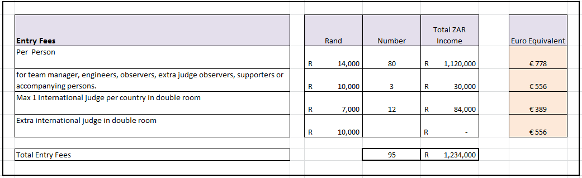
In accordance with the Rules and Regulations (D 3.3) each country nominating three or more crews has to send a minimum of one qualified FAI International Judge.

o) APPENDIX B I, Competition Budget
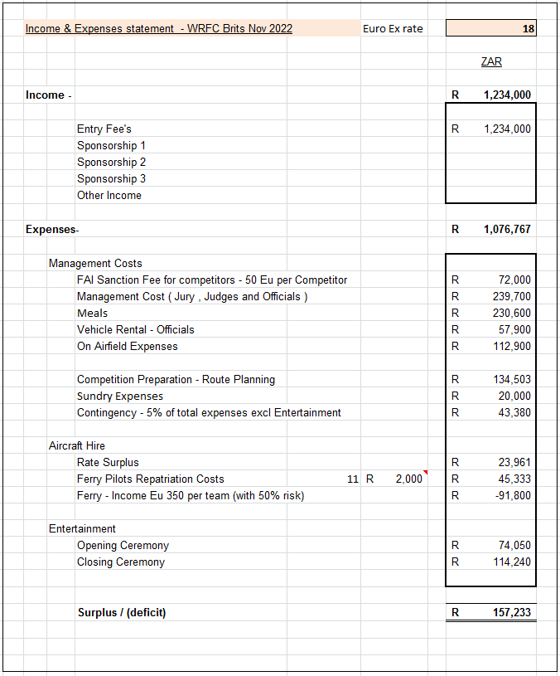

p) Any conditions concerning admission of participants to the country or location of the event.

No visa is required for most European citizens, provided your stay is less than 90 days, but please check with your travel agent as there may be specific requirements.

If you have children accompanying you, you will need their unabridged birth certificate and an affidavit from each parent authorising the trip.

Information can be obtained directly from the following website: http://www.home-affairs.gov.za/index.php/immigration-services/types-of-visas

q) Pilot Licence Validation requirements.

- Valid licence (PPL, CPL, ATPL) and medical certificate.
- The organising committee will arrange for temporary licence validations for the period of the competition and practice.
- Pilots wishing to fly either before or after this period may be required to write a South African Air Law Exam (PPL) and undergo a flight test.

r) Aircraft Hire costs.

The following type of aircraft will be available for rent: (Rental fees may be subject to change)

- Cessna 150/152 R 2500 – wet (Eu 135 indicative equivalent)
- Cessna 172 R 3000 – wet (Eu 160 indicative equivalent)

The rental of aircraft is anticipated to be handled by the organizer. Note that C150 may not be suitable due to the high density altitude of the airport. With summer temperature can reach a DA of 8000 ft.

Price will include aircraft insurance.

Expected hourly rental prices are calculated including fuel and oil.

Aircraft hire must be settled at the end of the training week, and at the end of the competition week.

Credit card facilities will be available (Master Card / Visa)
The aircraft will be delivered to the competition airfield and shall be given back at the end of competition, with full tanks and oil at maximum.
Surcharges for ferry flights will apply – indicative cost expected to be Eu 150 per team

s) Fuel Costs. & t) Oil Costs.

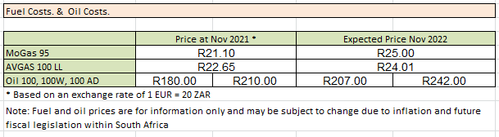

u) Aircraft Ferry Costs.

Most of the aircraft will have to be ferried from Johannesburg, a proportion of the ferry costs are included in the hire rates, a surcharge of an indicative amount of Eu 150 per team is to be expected, to be validated prior the competition start.

v) Signed by the President or the Secretary General of the National Aero Club who is a valid member of FAI.

Rob Jonkers
Chairman of SAPFA
Chairman Aero Club of South Africa

